CAED LAB #11

NAME: SHAHERYAR SIDDIQUI ID: FA17-BECE-0023

TASK1:

**Covert Fahrenheit to kelvin**

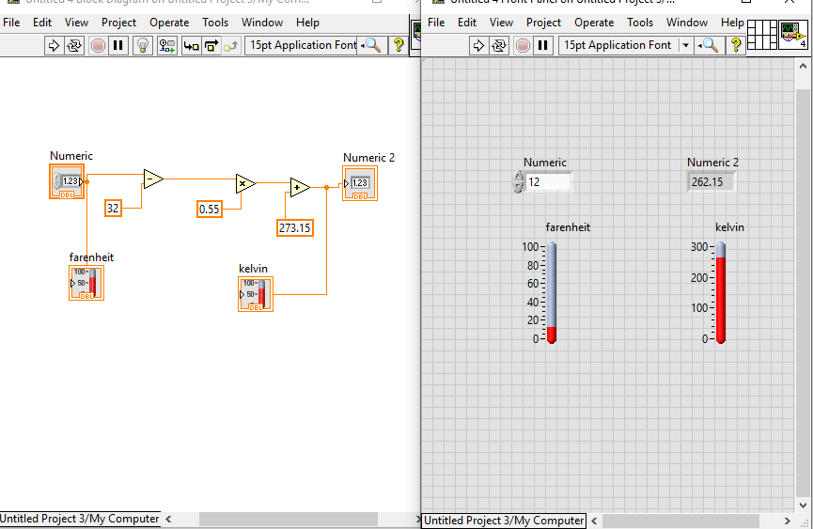

TASK2:

**Convert kelvin to degree Celsius**

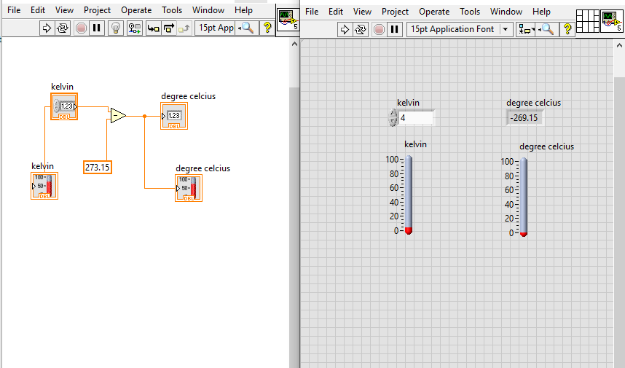

TASK3:

**Convert from kelvin to Fahrenheit**

